

Penetration Test Report



Presented to LionHealth

Resurgence Security Pte Ltd

Date issued: 7 August 2020

Table Of Contents:

* Executive Report
* Host Report
* Client-Side Test Report
* Attack Narrative / Activity Report
* User Report
* Vulnerability Report
* Recommendations

CONFIDENTIALITY

Both company and pen-testers came to a common agreement that the company Lion Health, has provided full access and permission for our assessor and penetration tester to perform pen-testing with the data required legally. Lion Health would not reserve any rights to sue the pen-testers for tampering with company confidential data.

In no event shall Resurgence Security be liable to LionHealth for special, incidental, collateral or consequential damages arising out of the use of information given.

Executive Summary

Resurgence Security has been engaged by Lion Health to conduct a comprehensive security assessment of Lion Health web application in order to determine existing vulnerabilities and establish the current level of security risk associated with the environment and the technologies in use. This assessment harnessed penetration testing techniques to provide Lion Health management with an understanding of the risks and security posture of their corporate environment.

Efforts were placed on identification and exploitation of security weakness that could allow a remote attacker to gain unauthorized access to the company’s data. The attacks were conducted with the level of access that the general internet user would have.

Summary of Results

Initial scans of LionHealth resulted in the discovery of SQL injection, also known as SQLI, is a common attack vector that uses malicious SQL code for backend database manipulation to access information that was not intended to be displayed.

SQL injection testing checks if it is possible to inject data into the application so that it executes a user-controlled SQL query in the database.

Testers find a SQL injection vulnerability if the application uses user input to create SQL queries without proper input validation.

A successful exploitation of this class of vulnerability allows an unauthorized user to access or manipulate data in the database.

This information may include any number of items, including sensitive company data, user lists or private customer details.

The impact SQL injection can have on a business is far-reaching. A successful attack may result in the unauthorized viewing of user lists, the deletion of entire tables and, in certain cases, the attacker gaining administrative rights to a database, all of which are highly detrimental to Lion Health.

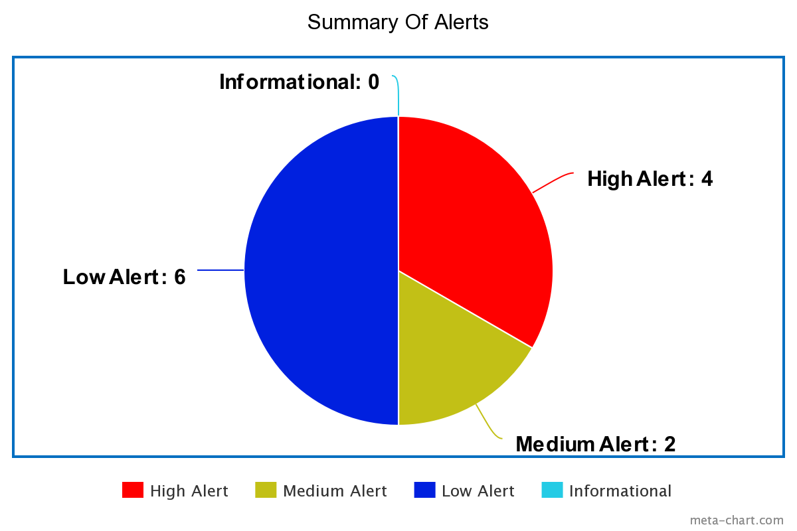

4 High alerts

The three identified high risk vulnerabilities are:

* SQL Injection
* Remote OS Command Injection
* 2 Cross Site Scripting (Reflected)

1. High (Low)
2. High (Medium)

2 Medium Alerts

The two identified medium risk vulnerabilities/recommendations are:

* Directory Browsing
* X-Frame-Options Header Not Set

6 Low Alerts

The six identified medium risk vulnerabilities/recommendations are:

* Absence of Anti-CSRF Tokens
* Cookie No HttpOnly Flag
* Cookie Without SameSite Attribute
* Server Leaks information via “X-Powered-By” HTTP Response Header Field
* Web Browser XSS Protection Not Enabled
* X-Content-Type-Options Header Missing

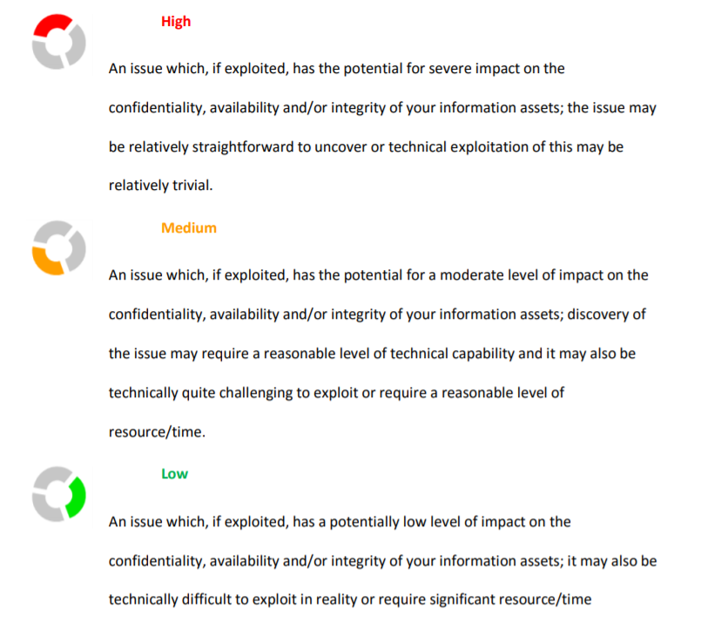

DISCOVERY & RECONNAISSANCE

As the first step of this engagement, Resurgence Security performed discovery and reconnaissance of the environment. This included performing network or application scans; reviewing the system, network or application architecture; or walking through a typical use case scenario for the environment. The results of discovery and reconnaissance determine vulnerable areas which may be exploited.

VALIDATION & EXPLOITATION

Resurgence Security used the results of the reconnaissance efforts as a starting point for manual attempts to compromise the Confidentiality, Integrity and Availability (CIA) of the environment and the data contained therein.

The highest risk vulnerabilities identified were selectively chosen by the assessor for exploitation attempts. The detailed results of these exploitation and validation tests follow in the sections below. While Resurgence Security may not have had time to exploit every vulnerability found, the assessor chose those vulnerabilities that provided the best chance to successfully compromise the systems in the time available.

TEST SCOPE

Testing was performed on September 1 – September 5, 2020. Additional days were utilized to produce the report.

The scope of the web application testing located at http://10.200.1.200/dvwa/vulnerabilities/sqli_blind/

Testing was performed using industry-standard penetration testing tools, which includes Nmap, SQLmap, Burp Suite, OWASP Zap.

**About Nmap**

* An open-source tool for vulnerability scanning and network discovery. Nmap is not limited to merely gathering information and enumeration, but it is also a powerful utility that can be used as a vulnerability detector or a security scanner.
* Runs on Windows, Linux, BSD, and Mac
* Written in [C](https://www.google.com/search?sxsrf=ALeKk03P3_Xr4DmdZZEeFek2zbu-EDObwg:1599315468475&q=C+programming+language&stick=H4sIAAAAAAAAAOPgE-LUz9U3MDIuTzJR4gAxDUvMkrSUMsqt9JPzc3JSk0sy8_P0i_PTSsoTi1KtyosyS0pS8xQy8xaxijkrFBTlpxcl5uZm5qUr5CTmpZcmpqfuYGUEAH45jcJXAAAA&sa=X&ved=2ahUKEwijh4ezmtLrAhXWXCsKHfgoB3wQmxMoATAeegQIDBAD), [C++](https://www.google.com/search?sxsrf=ALeKk03P3_Xr4DmdZZEeFek2zbu-EDObwg:1599315468475&q=C%2B%2B&stick=H4sIAAAAAAAAAOPgE-LUz9U3MDIuTzJR4gAxs9IL07WUMsqt9JPzc3JSk0sy8_P0i_PTSsoTi1KtyosyS0pS8xQy8xaxMjtra-9gZQQA8ty_k0QAAAA&sa=X&ved=2ahUKEwijh4ezmtLrAhXWXCsKHfgoB3wQmxMoAjAeegQIDBAE), [Python](https://www.google.com/search?sxsrf=ALeKk03P3_Xr4DmdZZEeFek2zbu-EDObwg:1599315468475&q=Python&stick=H4sIAAAAAAAAAOPgE-LUz9U3MDIuTzJR4gAxTasM47WUMsqt9JPzc3JSk0sy8_P0i_PTSsoTi1KtyosyS0pS8xQy8xaxsgVUlmTk5-1gZQQAV7canUcAAAA&sa=X&ved=2ahUKEwijh4ezmtLrAhXWXCsKHfgoB3wQmxMoAzAeegQIDBAF) and Lua programming language

**About SQLmap**

* An open-source tool used in penetration testing to detect and exploit SQL injection flaws. SQLmap automates the process of detecting and exploiting SQL injection. SQL Injection attacks can take control of databases that utilize SQL. They can affect any website or web app that may have a SQL database linked to it, such as MySQL, SQL Server, Oracle and many others. SQLmap can help in finding these vulnerabilities.
* Runs on Python
* Written in [Python](https://www.google.com/search?sxsrf=ALeKk03P3_Xr4DmdZZEeFek2zbu-EDObwg:1599315468475&q=Python&stick=H4sIAAAAAAAAAOPgE-LUz9U3MDIuTzJR4gAxTasM47WUMsqt9JPzc3JSk0sy8_P0i_PTSsoTi1KtyosyS0pS8xQy8xaxsgVUlmTk5-1gZQQAV7canUcAAAA&sa=X&ved=2ahUKEwijh4ezmtLrAhXWXCsKHfgoB3wQmxMoAzAeegQIDBAF) programming language

**About OWASP Zap**

* An open-source web application vulnerabilities scanner. It is intended to be used by both those new to application security as well as professional penetration testers. It is one of the most active Open Web Application Security Project projects and has been given Flagship status.
* Runs on [Linux](https://www.google.com/search?sxsrf=ALeKk01ucL-YR-sX1P8z7GmLF6SnC3PpLw:1599315863318&q=Linux&stick=H4sIAAAAAAAAAONgVuLUz9U3SCuoqipYxMrqk5lXWgEATgerNhUAAAA&sa=X&ved=2ahUKEwisparvm9LrAhVb7nMBHd5_ApYQmxMoATAbegQIERAD), Windows and [OS X](https://www.google.com/search?sxsrf=ALeKk01ucL-YR-sX1P8z7GmLF6SnC3PpLw:1599315863318&q=OS+X&stick=H4sIAAAAAAAAAONgVuLQz9U3MDWtLFrEyuIfrBABANwDvJoTAAAA&sa=X&ved=2ahUKEwisparvm9LrAhVb7nMBHd5_ApYQmxMoAjAbegQIERAE)
* Written in Java programming language

Attack Narrative/ Activity Report

**Phase 1 : Gathering Information & Vulnerability Analysis**

To test the security posture of the internal network, we began with a reconnaissance and host discovery phase during which we used portscans to fingerprint the operating systems, software, and services running on each target host. After fingerprinting the various targets and determining open ports and services enabled on each host, we executed a vulnerability enumeration phase, in which we listed all potential vulnerabilities affecting each host and developed a list of viable attack vectors.

Four possible cyber attacks that may happened:

1. Cross site scripting

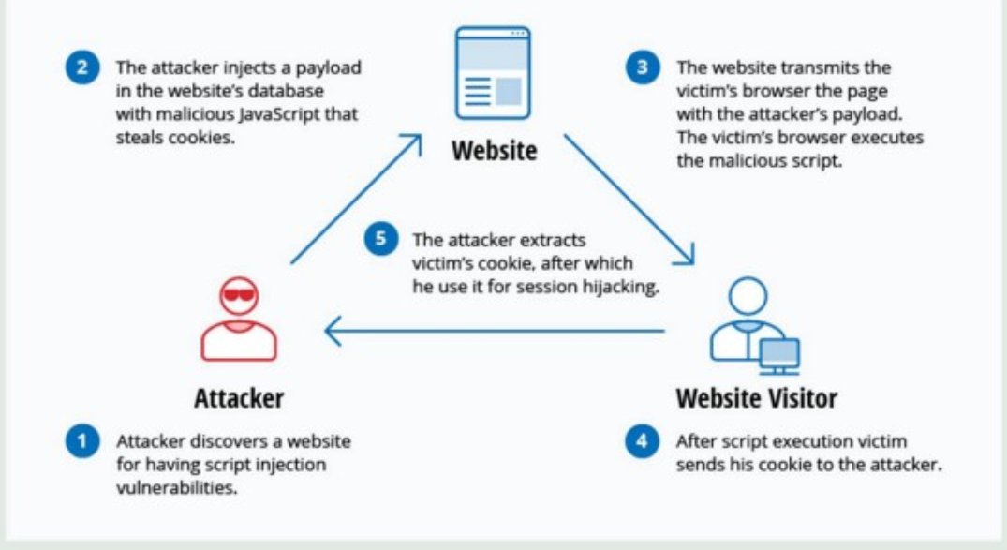

A hacker can enter their own malicious codes which will be sent to the database. Once inside, the code will get executed. There are numerous codes hackers can insert into the website to run all sorts of malicious activities like creating a new website admin or stealing cookies.Once the code is executed, the hackers are able to retrieve your session cookie and session ID. **They will be able to recreate your session and pose as you on that website.**

1. Distributed Denial Of Service

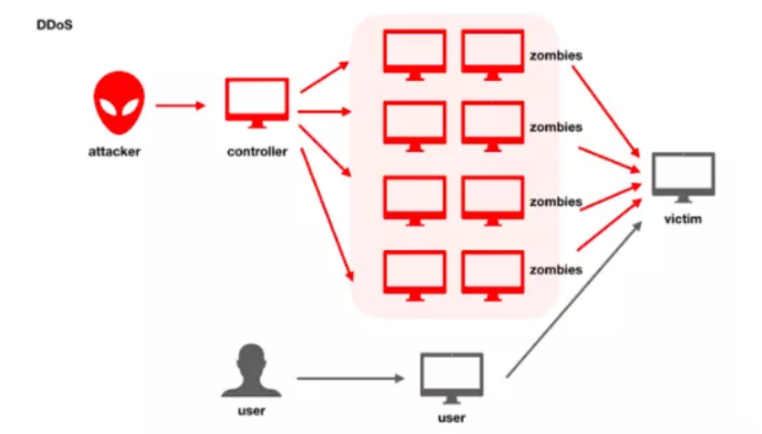

A **Distributed Denial of Service (DDoS) attack** is a non-intrusive internet attack made to take down the targeted website or slow it down by flooding the network, server or application with fake traffic. When against a vulnerable resource-intensive endpoint, even a tiny amount of traffic is enough for the attack to succeed.

1. Denial-of-Service

A **Denial-of-Service (DoS) attack** is an attack meant to shut down a machine or network, making it inaccessible to its intended users. DoS attacks accomplish this by flooding the target with traffic, or sending it information that triggers a crash.

1. Brute Force Attack

**Brute Force attack** is an attempt to get through the authentication phase of a server or application by trying numerous combinations of credentials in order to find a valid set of credentials for this resource. It can slow down sites (or cause it to stop responding) because of repeated server requests.

*result of Nmap output 1*

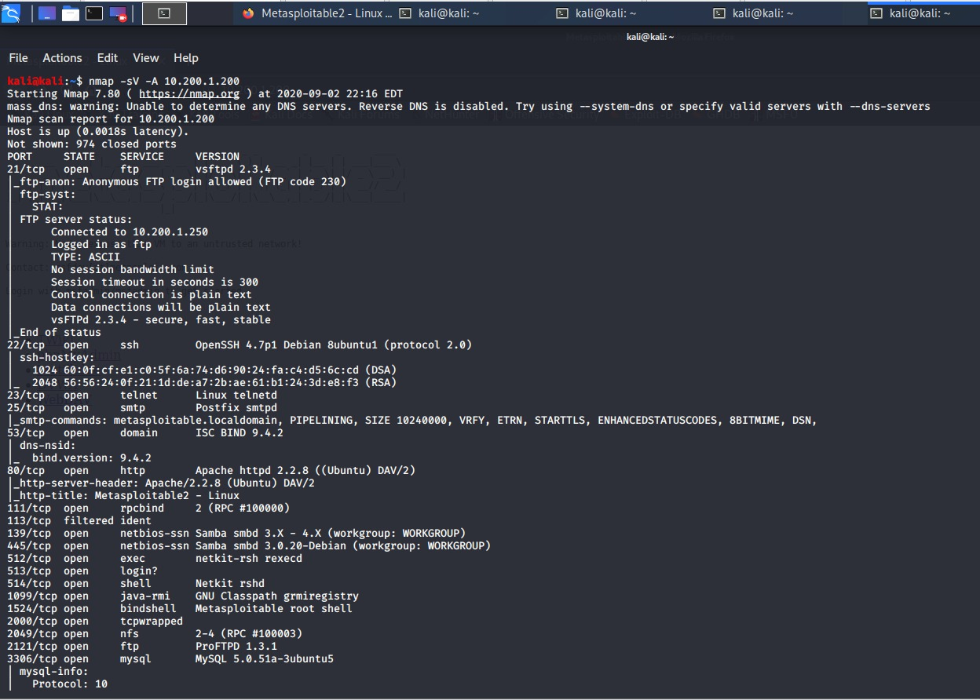

*result of Nmap output 2*

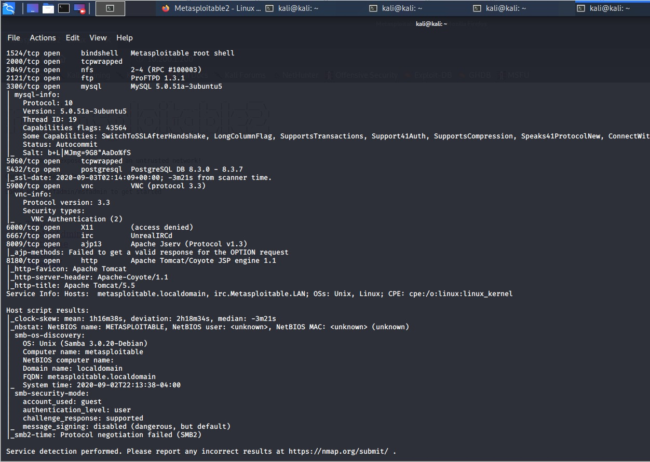

List of Port states, Protocol used, Services and Version detection discovered in the scan.

|  |  |  |  |  |
| --- | --- | --- | --- | --- |
| **Port** | **Protocol** | **State** | **Service** | **Version** |
| **21** | **tcp** | **open** | **ftp** | **Vsftpd 2.3.4** |
| **22** | **tcp** | **open** | **ssh** | **OPenSSH 4.7pl Debian 8 Ubuntu 1 (Protocol 2.0)** |
| **23** | **tcp** | **open** | **telnet** | **Linux telnetd** |
| **25** | **tcp** | **open** | **smtp** | **Postfix smtpd** |
| **53** | **tcp** | **open** | **domain** | **ISC BIND 9.4.2** |
| **80** | **tcp** | **open** | **http** | **Apache httpd 2.2.8 ((Ubuntu) DAV/2)** |
| **111** | **tcp** | **open** | **rpcbind** | **2 (RPC # 100000)** |
| **113** | **tcp** | **filtered** | **ident** |  |
| **139** | **tcp** | **open** | **Netbios-ssn** | **Samba smbd 3.x 4.x (workgroup: WORKGROUP)** |
| **445** | **tcp** | **open** | **Netbios-ssn** | **Samba smbd 3.0.20-Debian (workgroup: WORKGROUP)** |
| **512** | **tcp** | **open** | **exec** | **Netkit-rsh rexecd** |
| **513** | **tcp** | **open** | **login** |  |
| **514** | **tcp** | **open** | **shell** | **netkit rshd** |
| **1099** | **tcp** | **open** | **java-rmi** | **GNU Classpath grmiregistry** |
| **1524** | **tcp** | **open** | **bindshell** | **Metasploitable root shell** |
| **2000** | **tcp** | **open** | **tcpwrapped** |  |
| **2049** | **tcp** | **open** | **nfs** | **2-4 (RPC #100003)** |
| **2121** | **tcp** | **open** | **ftp** | **ProFTPD 1.3.1** |
| **3306** | **tcp** | **open** | **mysql** | **MySQL 5.0.51 a- 3 Ubuntu 5** |
| **5060** | **tcp** | **open** | **tcpwrapped** |  |
| **5432** | **tcp** | **open** | **postgresql** | **PostgreSQL DB 8.3.0 – 8.3.7** |
| **5900** | **tcp** | **open** | **vnc** | **VNC (protocol 3.3)** |
| **6000** | **tcp** | **open** | **X11** | **(access denied)** |
| **6667** | **tcp** | **open** | **irc** | **UnrealIRCd** |
| **8009** | **tcp** | **open** | **Ajpl3** | **Apache Jserv (Protocol v1.3)** |
| **8180** | **tcp** | **open** | **http** | **Apache Tomcat/Coyote JSP engine 1.1** |

**Phase 2 : Web Application Analysis**

Carrying out an OWASP Zap active scan to capture all actions between the browser and the web application by attacking the website with known techniques to find security vulnerabilities and loopholes.

*result of OWASP Zap scan*

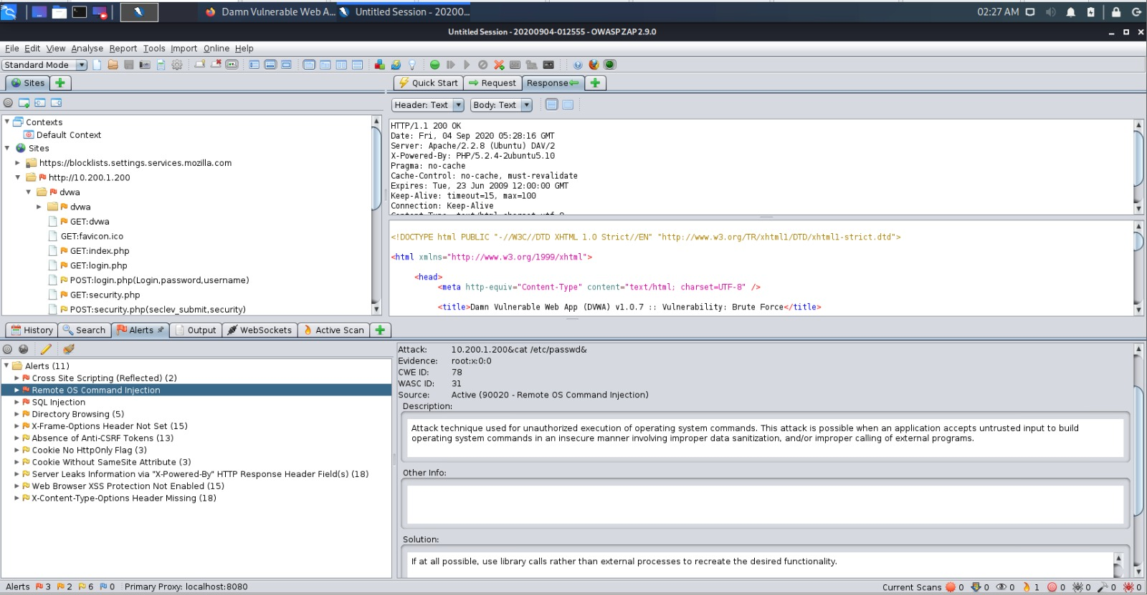

**Vulnerability report**



**Vulnerability details and Mitigation**

**1 - SQL Injection**

* Method : GET
* Parameter : id
* Attack : john’OR’1’=’1’ --
* Instances : 1
* Impact : Attackers can use SQL Injection vulnerabilities to bypass application security measures. They can go around authentication and authorization of a web page or web application and retrieve the content of the entire SQL database. They can also use SQL Injection to add, modify, and delete records in the database. Criminals may use it to gain unauthorized access to your sensitive data such as customer information, personal data, trade secrets.
* CWE ID : 89
* Mitigation and remediation : Quote and backslash escaping for strings is the most popular and effective strategy against SQL injection attacks. It should be performed according to requirements of each particular database. Casting operations of digits is usually enough to defend application against SQL injection. In certain cases, parameter values should be checked against existing templates and treated according to these templates.

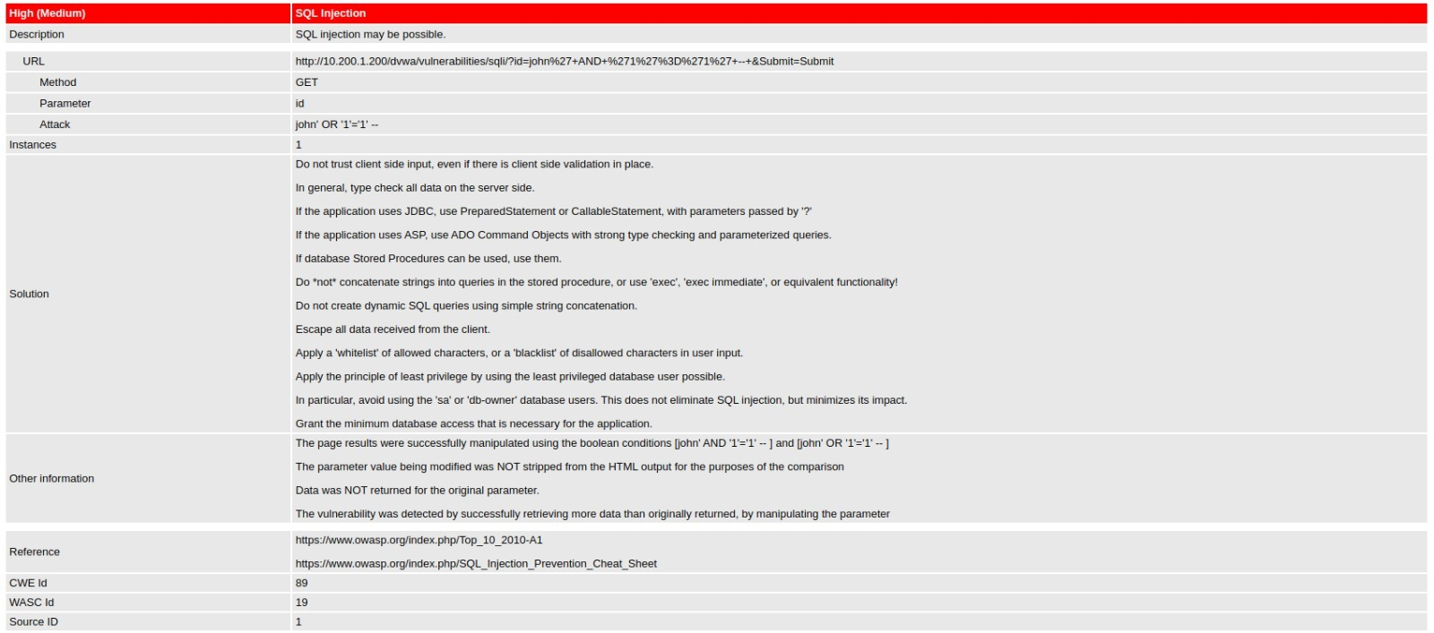

**2 - Remote OS Command Injection**

* Method : POST
* Parameter : ip
* Attack : 10.200.1.200&cat/etc/passwd&
* Evidence : root:x:0:0
* Instanances : 1
* Impact : It allows the attacker to execute arbitrary operating system (OS) commands on the server that is running an application, and typically fully compromise the application and all its data.
* CWE id : 78
* Mitigation and remediation : To defend systems from this weakness, developers need to use library calls to create the desired functionality without external input. When external input is inescapable, developers need to use secure input and output a way would ensuring that the data appears as it should before being processed, by using an appropriate regular expression.

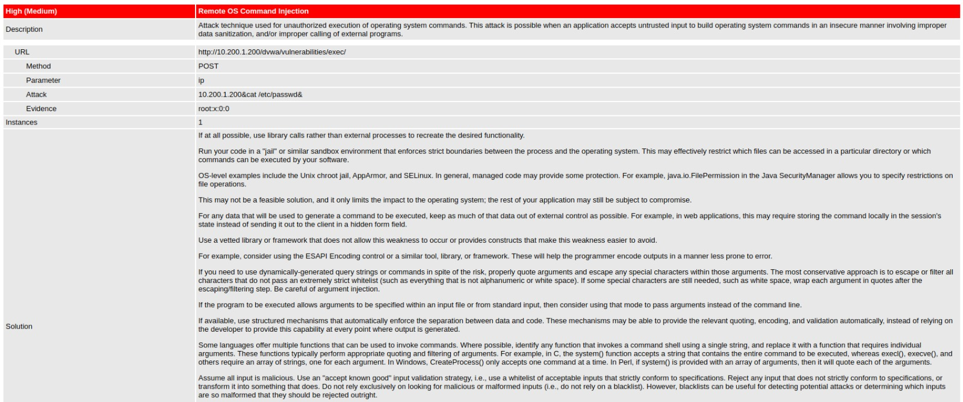

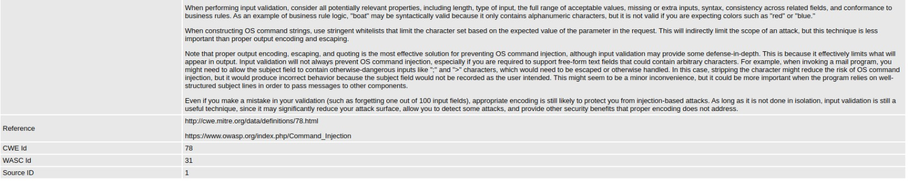

**3 & 4 - Cross Site Scripting (Reflected )**

* Method : GET
* Parameter : name
* Attack : </pre><script>alert(1):</script><pre>
* Evidence : </pre><script>alert(1):</script><pre>
* Instances : 1
* Impact : It ranges from user's Session Hijacking, and if used in conjunction with a social engineering attack it can also lead to exposure of sensitive data, CSRF attacks and other security vulnerabilities. By exploiting a cross-site scripting vulnerability an attacker can impersonate the victim and take over the account.
* CWE id : 79
* Mitigation and remediation : Firstly never insert untrusted input directly into the script, CSS, in a tag name, attribute name, attribute level and HTML comment as they cannot be sanitized correctly and can be potentially used to perform cross-site scripting attacks, performing sanitation of input data before inserting it into the page content, use a native API and additional software whenever possible. Lastly, Always use preset character encoding of the displayed page.

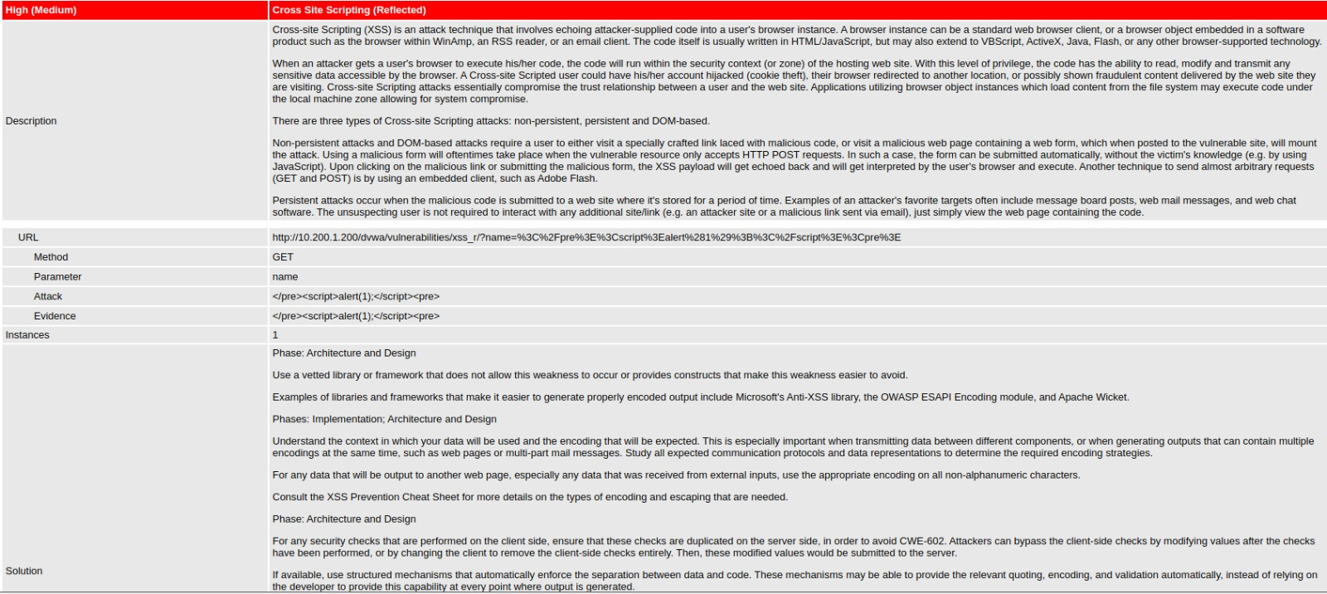

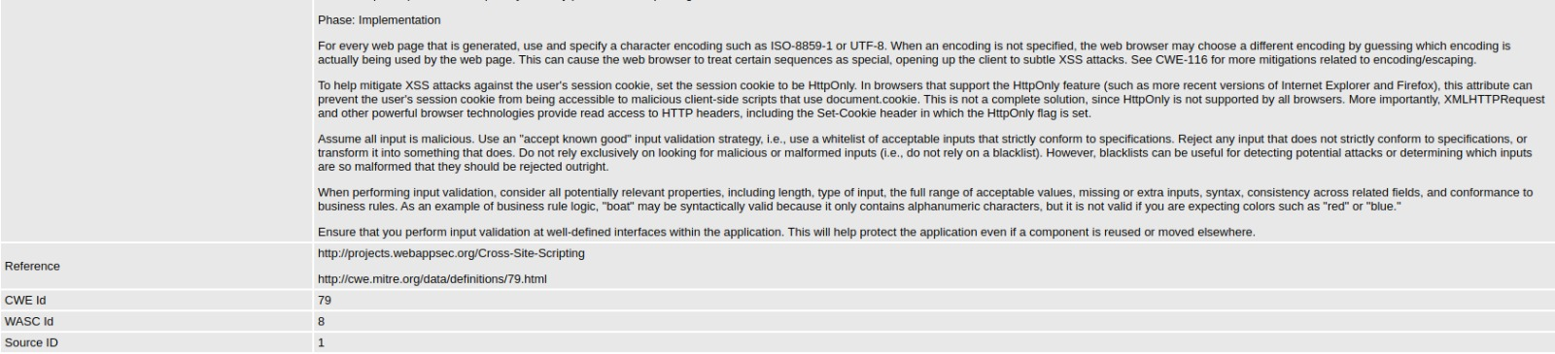

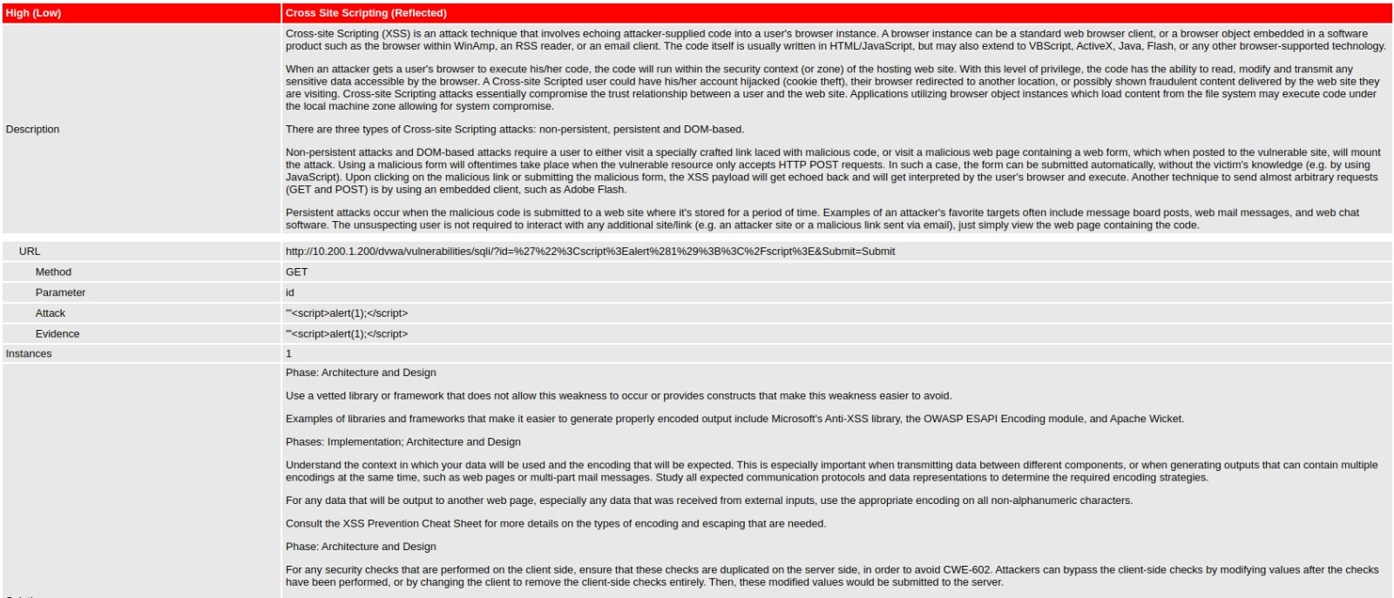

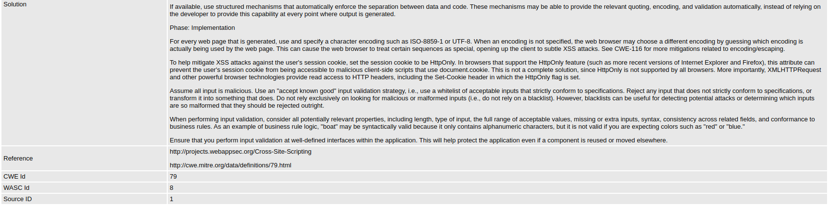

**5 - Directory Browsing**

* **Impact :** Exposing the contents of a directory can lead to an attacker gaining access to source code or providing useful information for the attacker to devise exploits, such as creation times of files or any information that may be encoded in file names.
* **CWE id** : 548
* **Mitigation and remediation** : Configure the web server to prevent directory listings for all paths beneath the web root or place into each directory a default file such as index.htm so that the web server will display instead of returning a directory listing.

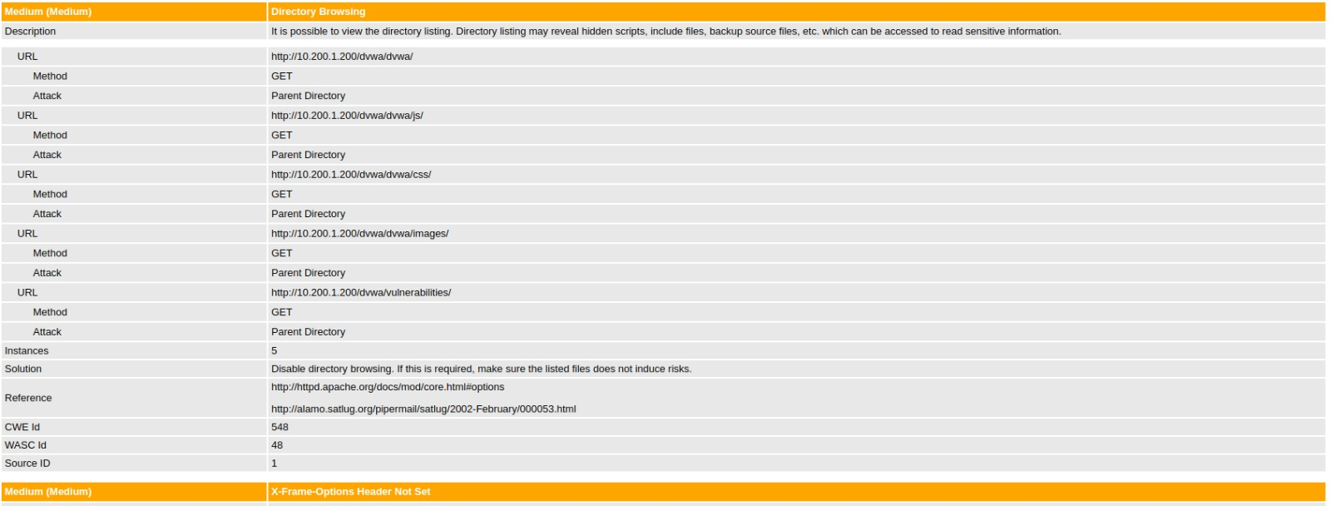

**6 - X-Frame-Options Header not set**

* **Impact :** it means that this website could be at risk of a clickjacking attack. Clickjacking is when an attacker uses multiple transparent or opaque layers to trick a user into clicking on a button or link on a framed page when they were intending to click on the top level page. Thus, the attacker is "hijacking" clicks meant for their page and routing them to another page, most likely owned by another application, domain, or both.
* **CWE id :** 16
* **Mitigation and remediation :** HTTP security headers provide yet another layer of security by helping to mitigate attacks and security vulnerabilities by telling your browser how to behave. use the X-Frame-Options header on pages which should not be allowed to render a page in a frame.
* On linux hosting accounts
* The **X-Frame-Options** header is sent by default with the value **sameorigin**. Therefore, if you want to share content between multiple sites that you control, you must disable the **X-Frame-Options** header. To do this, add the following line to the *.htaccess* file in the directory where you want to allow remote access



* On windows hosting accounts
* The **X-Frame-Options** header is not sent by default. Therefore, if you want to share content between multiple sites that you control, no extra configuration is necessary. However, if you *do* want to restrict loading content between sites, you must send the **X-Frame-Options** header. To do this, add the following lines to the *web.config* file in the directory where you want to restrict remote access

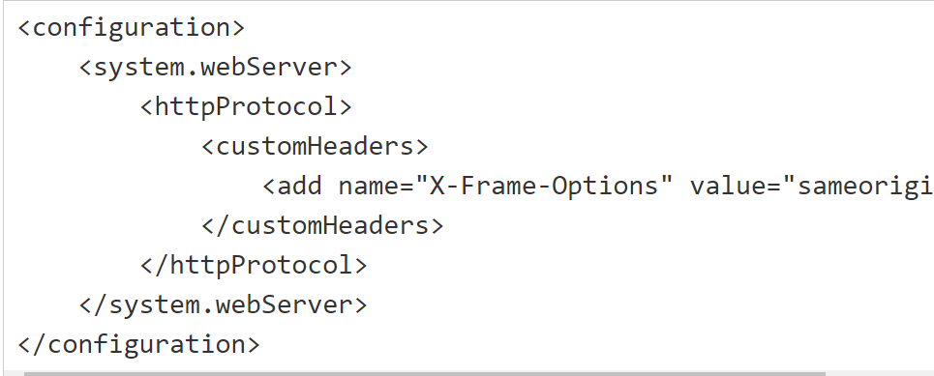

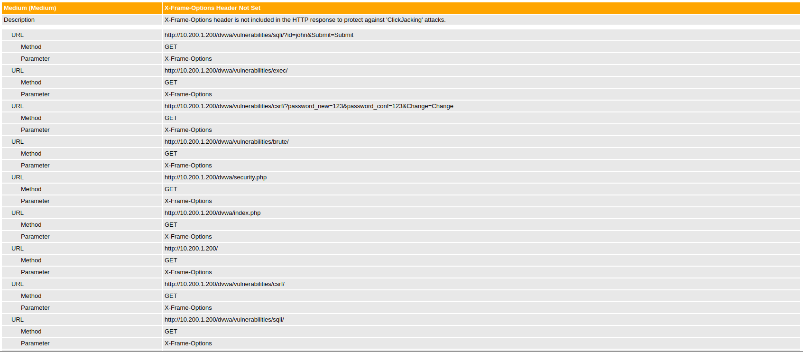

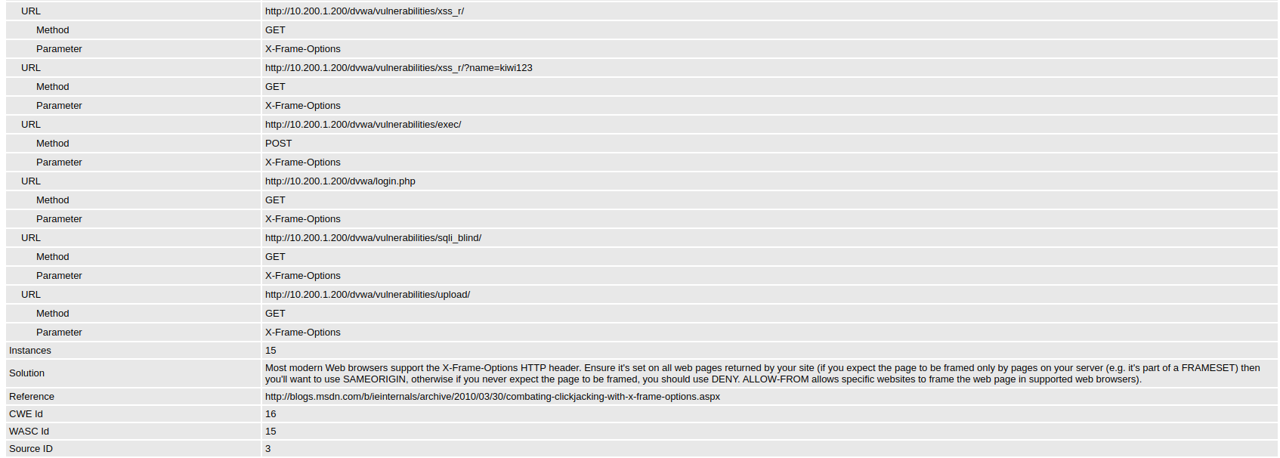

**7 - Cookies without SameSite Attribute**

* **Impact :** It could lead to Cross-site Request Forgery (CSRF). It is carried out by misusing a session belonging to an authorized user by using this browser behavior.
* CWE : 16

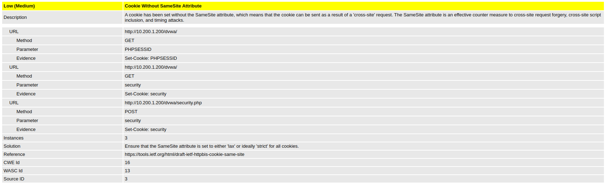

**8 - X-Content-Type-Options Header Missing**

* **Impact:** This allows older versions of Internet Explorer and Chrome to perform MIME-sniffing on the response body, potentially causing the response body to be interpreted and displayed as a content type other than the intended content type.

The problem arises once a website allows users to upload content which is then published on the web server. If an attacker can carry out XSS (Cross-site Scripting) attack by manipulating the content in a way to be accepted by the web application and rendered as HTML by the browser, it is possible to inject code in e.g. an image file and make the victim execute it by viewing the image.

* CWE id : 16

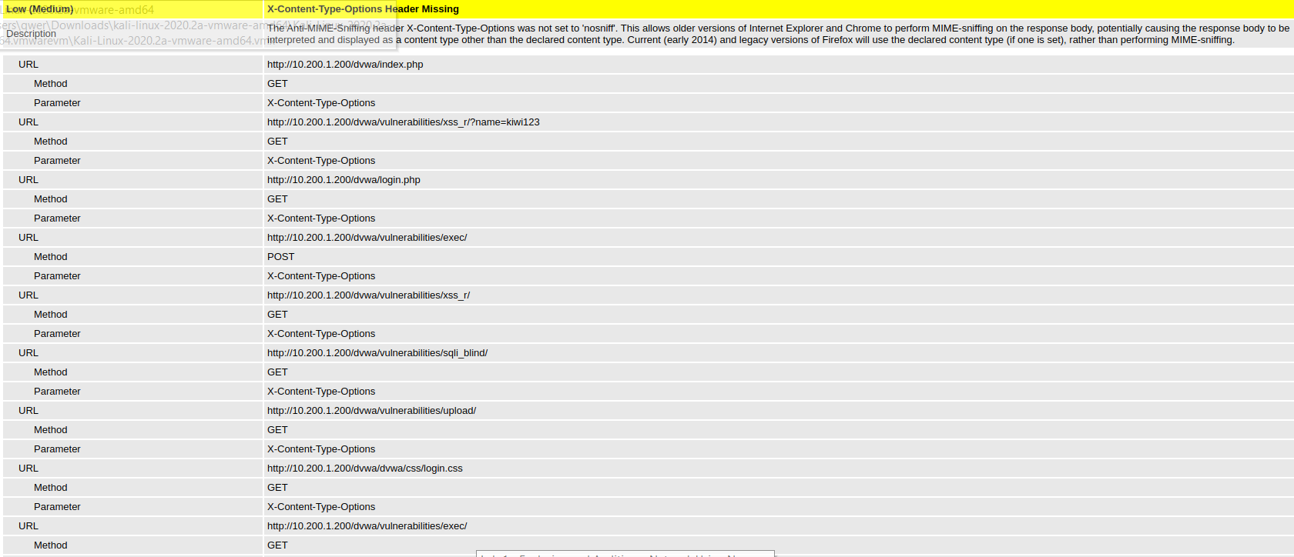

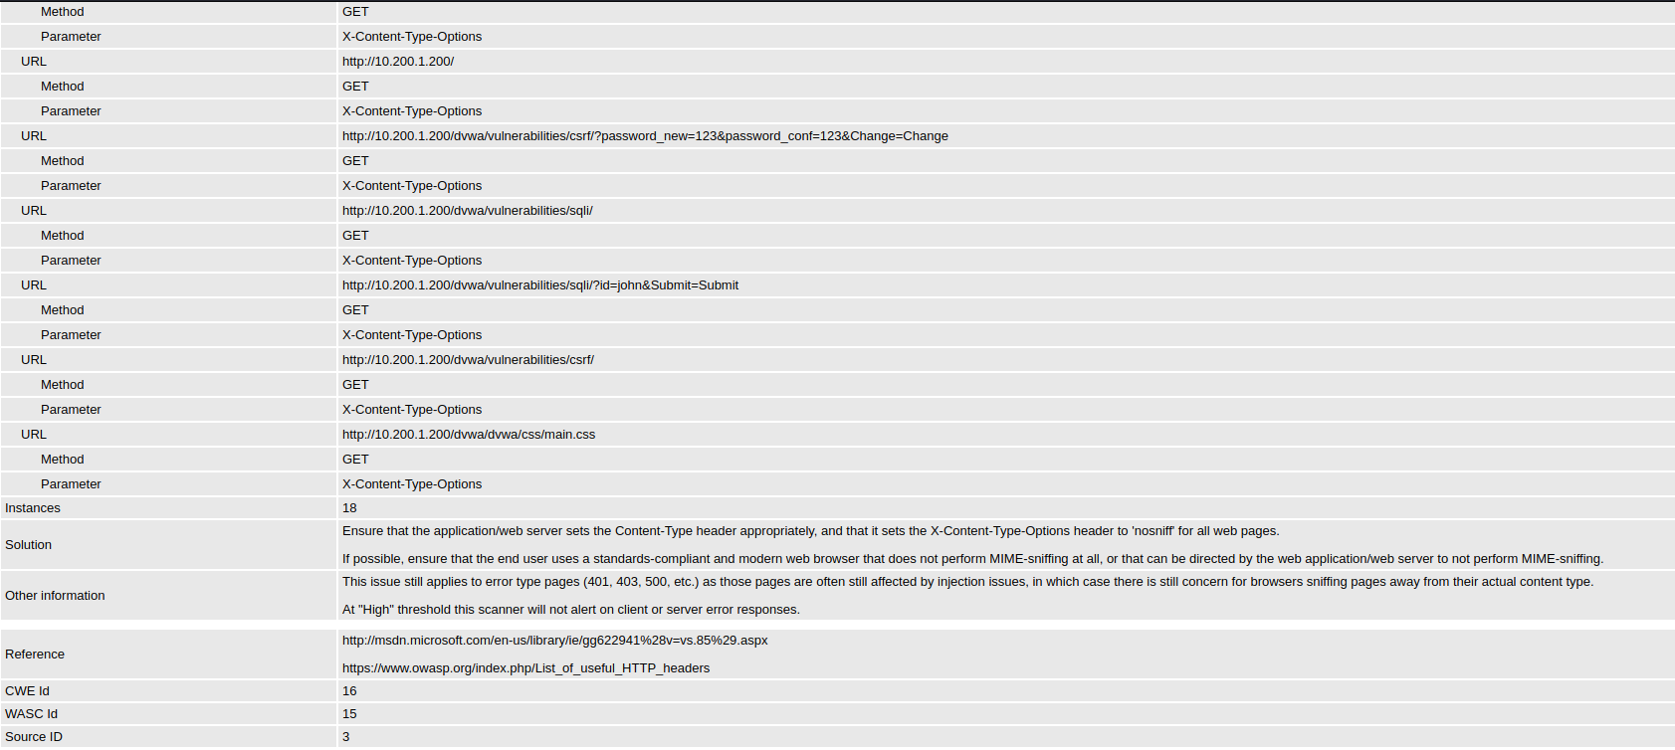

**9 - Absence of Anti-CSRF Tokens**

* **Impact :** hackers can trick an innocent user to click a believable link. If this user is already logged into a website the hacker wants to access, the hacker can surf on the already authenticated session and make a request to a site the user didn't intend to make. Being that the user already authenticated, the site cannot distinguish between the forged or legitimate request
* CWE id : 352

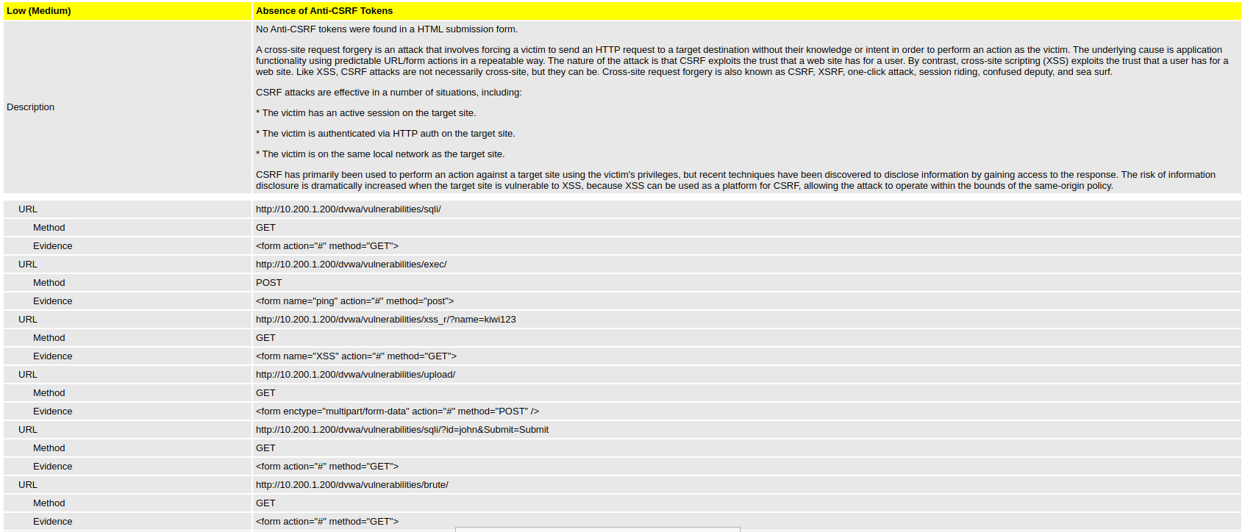

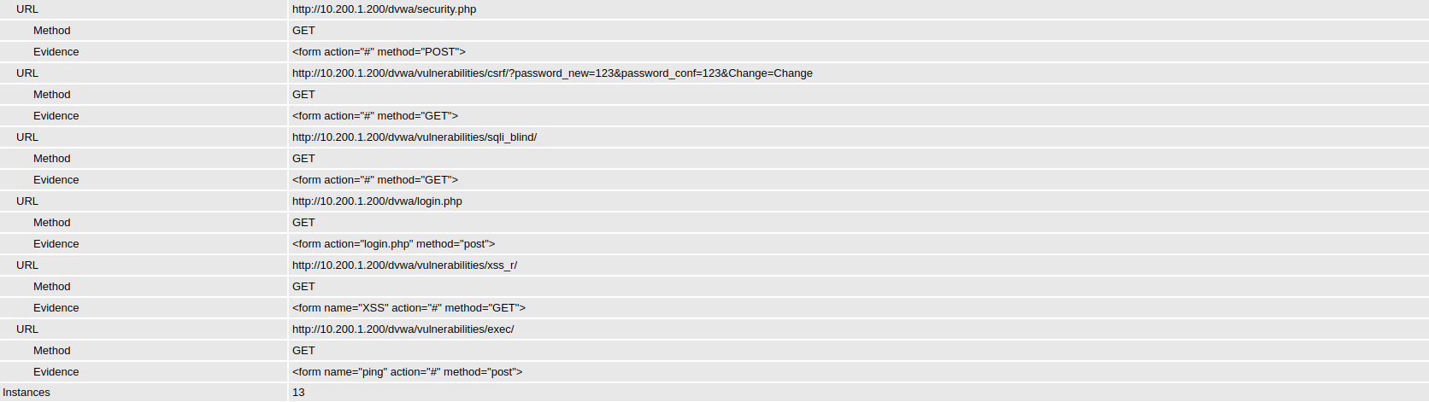

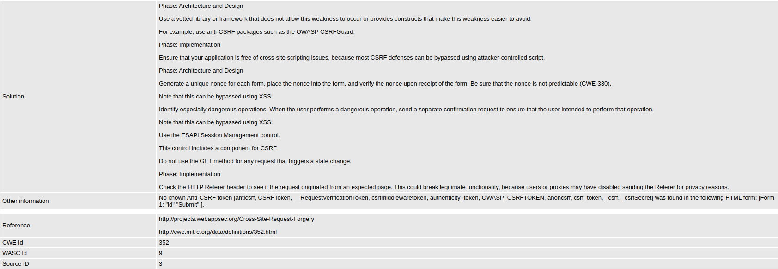

**10 - Server Leaks Information via "X-Powered-By" HTTP Response Header Field(s)**

* **Impact :** Access to such information may facilitate attackers identifying other frameworks/components your web application is reliant upon and the vulnerabilities such components may be subject to.
* CWE id : 200

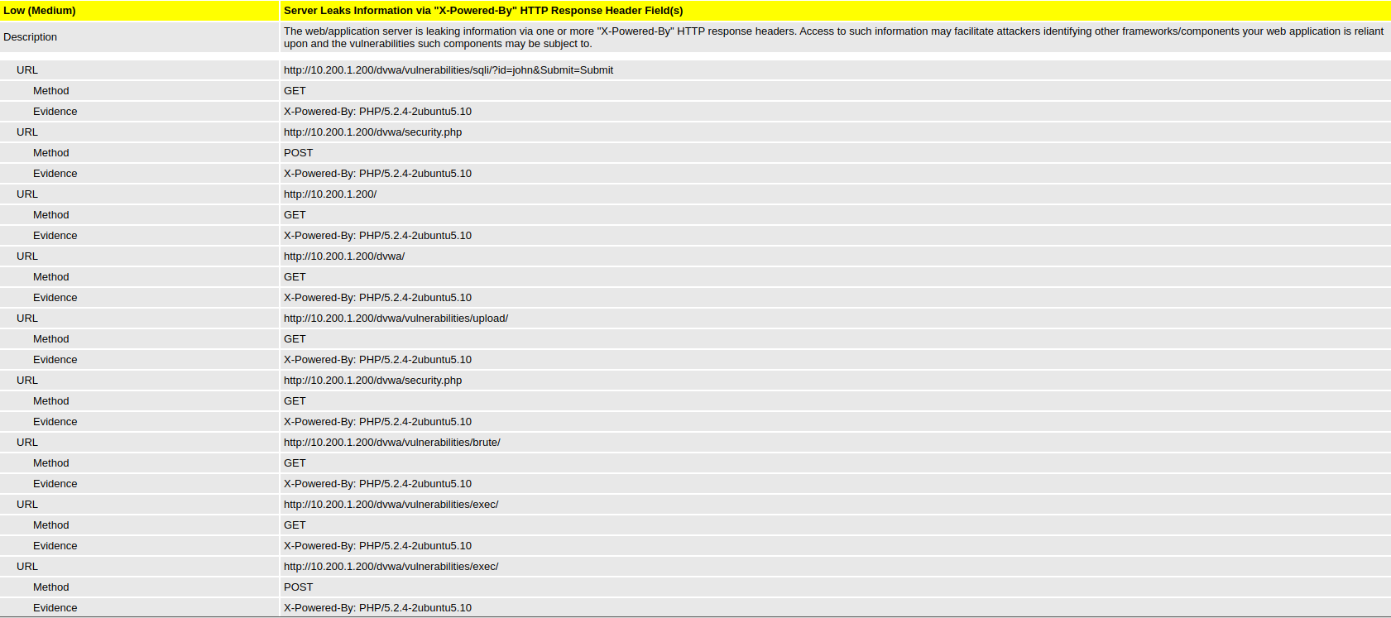

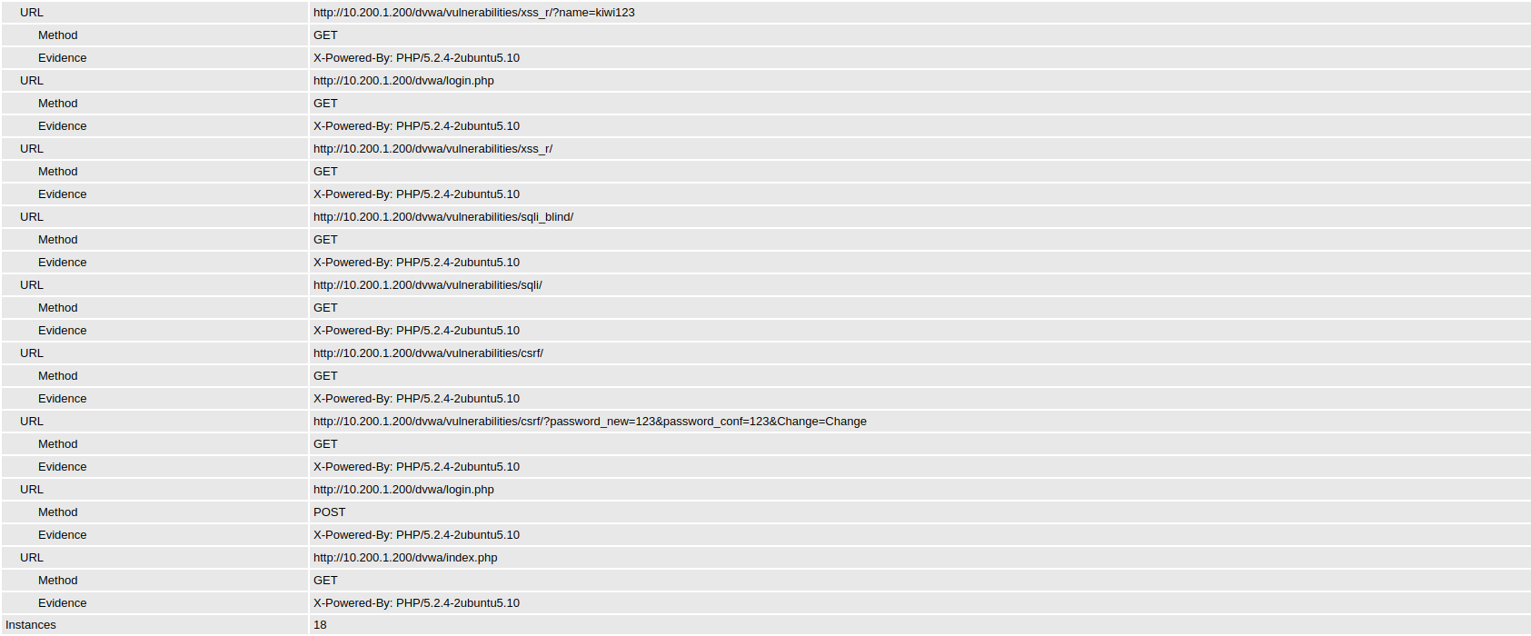



**11 - Web Browser XSS Protection Not Enabled**

* **Impact :** Cross-site scripting is able to inject malicious code into the vulnerable web
* CWE id : 933

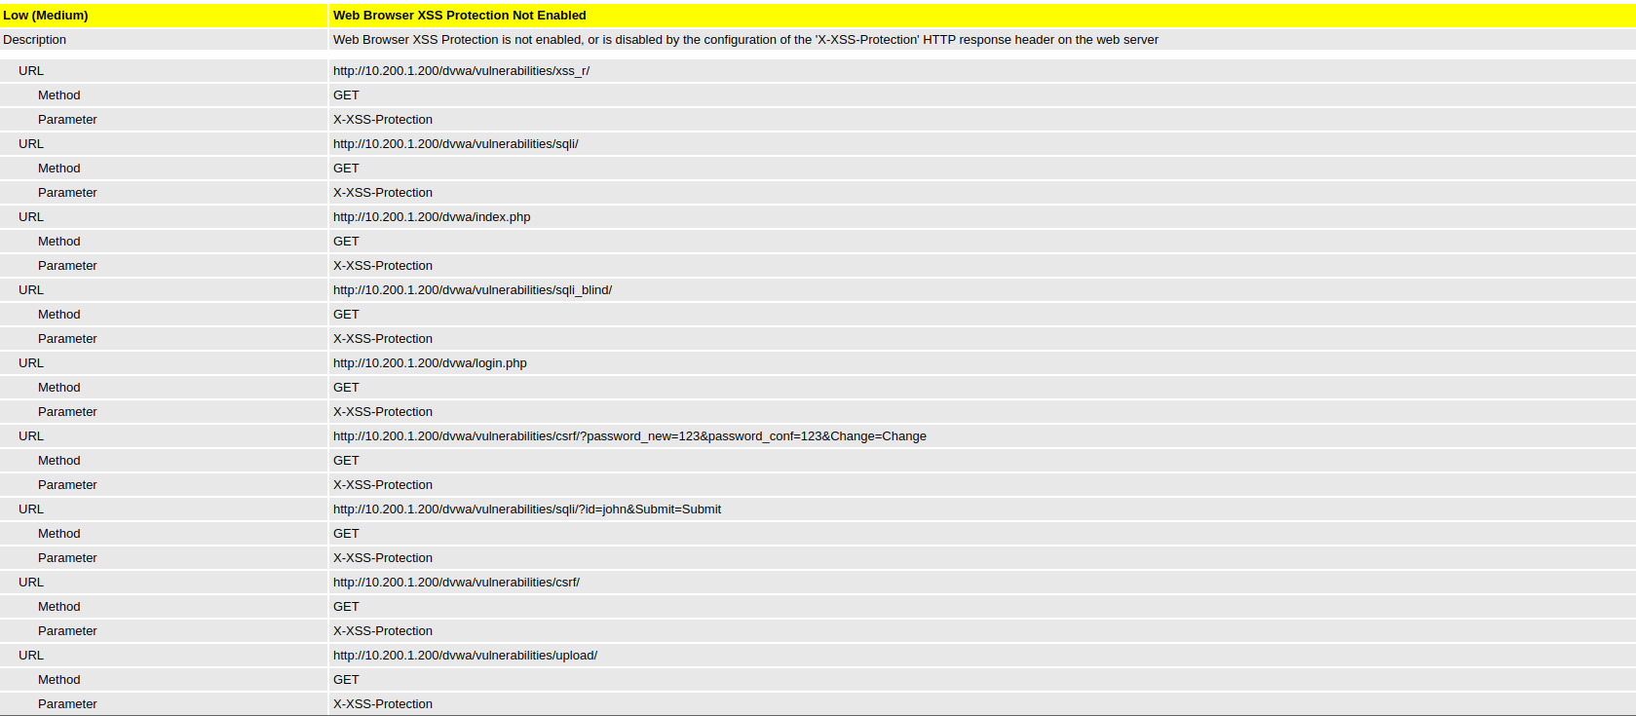

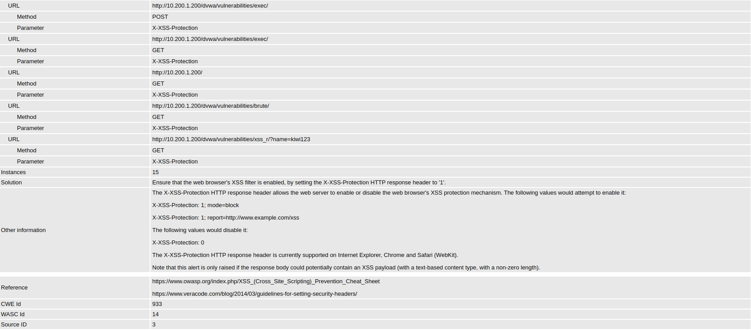

**12 - Cookie No HttpOnly Flag**

* **Impact :** If the HttpOnly flag is not set, then sensitive information stored in the cookie may be exposed to unintended parties. If the cookie in question is an authentication cookie, then not setting the HttpOnly flag may allow an adversary to steal authentication data (e.g., a session ID) and assume the identity of the user.
* CWE id : 16

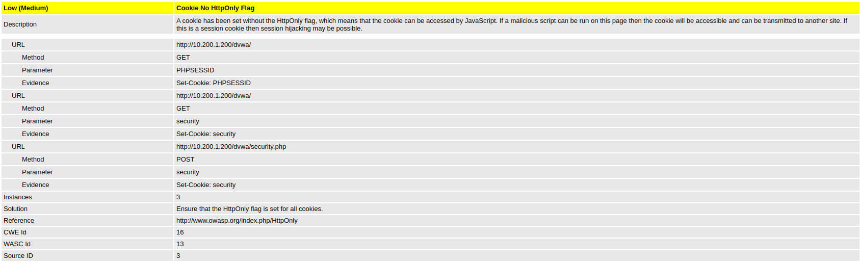

**Summary of Alerts**

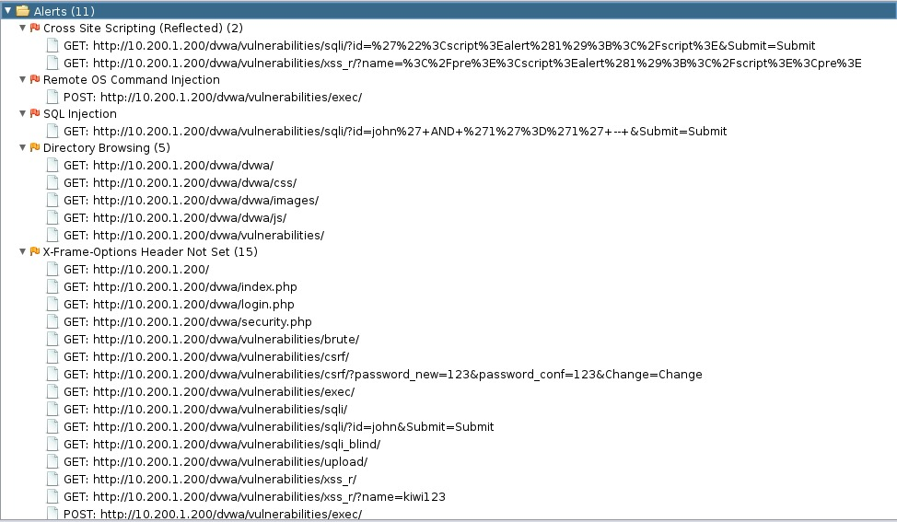

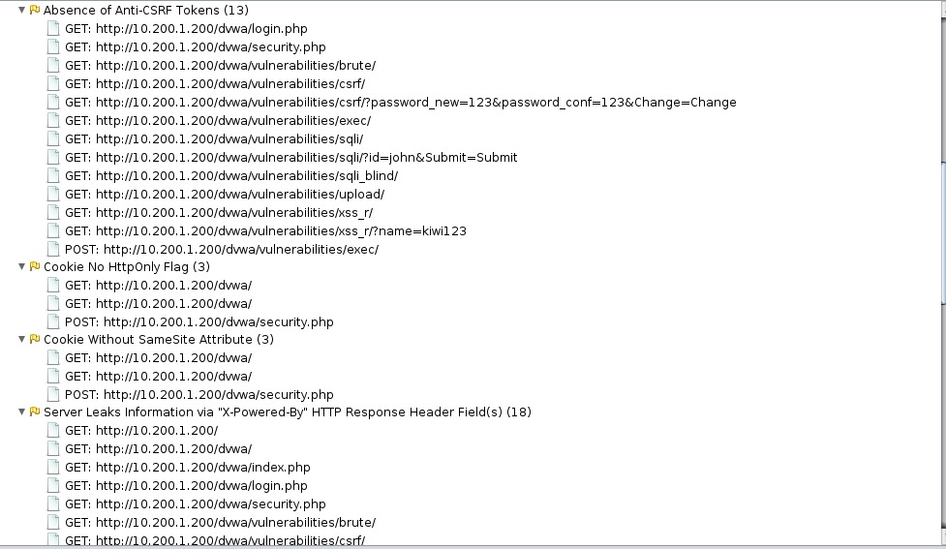

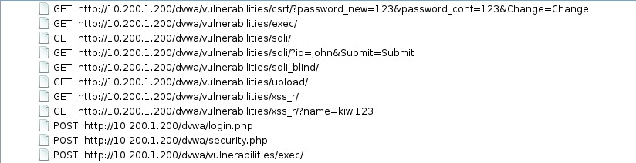

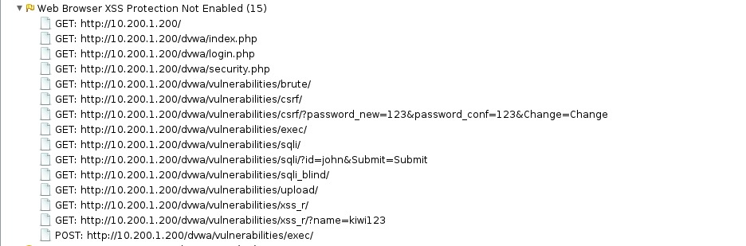

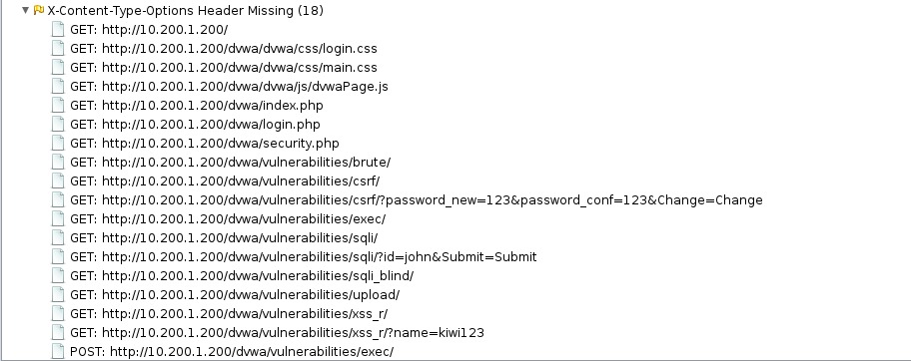

With the information in hand, the team was able to identify three different severity of vulnerabilities found in the web.

These vulnerabilities can give hackers ample opportunities to exploit the system in many different ways and gain benefits out of it, such as; unauthorized access into databases and steal sensitive data or add, modify, and delete records in the database or rather, inserting of malicious software onto the web application server et cetera.

SQL injection attacks pose a serious security threat to organizations. A successful SQL injection attack can result in confidential data being deleted, lost or stolen; websites being defaced; unauthorized access to systems or accounts and, ultimately, compromise of individual machines or entire networks.

Hence, we would like to look into the issue comprehensively and thoroughly to remediate the vulnerability. The team would like to propose a solution of demonstrating a simulated SQL injection attack to show the downside of the outcome.

**Phase 3 : Simulating blind SQL injection attack**

Blind SQL injection is a type of SQL injection attack that asks the database true or false questions and determines the answer based on the application response.

Sites that are vulnerable to blind SQL injection don’t address the underlying problem, but they can still allow user inputs to be treated as part of the SQL itself.

**Technique A:**

The use of SQL function will allow us to check the substring of the output. Further utilise a method called binary search, we can use a substring function to find out whether the value for the queries is higher, lower or equals to ; and from there, we can slowly build up the contents of the database bit by bit.



(This is an example of searching whether the output of the substring is after ‘n’ in the alphabets)

*client’s web application* *example*

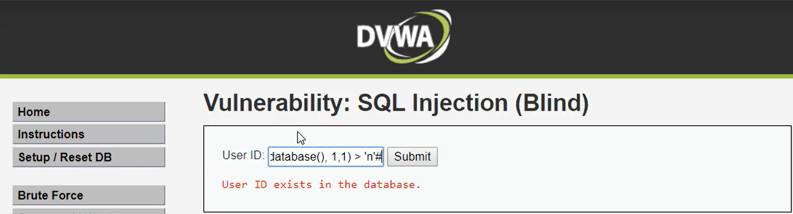

This is the basic idea. It can be continued to find the first letter of the database, then we go for the 2nd and 3rd letter and so on.

The downside of manual Blind SQL injections are proven to be time-consuming and tiresome, as it requires some time for hackers to guess and check their way into the databases.

**Technique B**:

By using an automated method known as SQLmap tool, it can save us a great amount of time with its efficiency and it is capable of detecting and exploiting many different types of SQL databases using many types of different SQL injection attacks.

In this case, the team had decided to take advantage of it by using this method.

**Walking through steps by steps explanations of achieving technique two**

1) With the help of burp suite, we first extract required information from the targeted web application - The url and cookie sessionid

*burp suite*

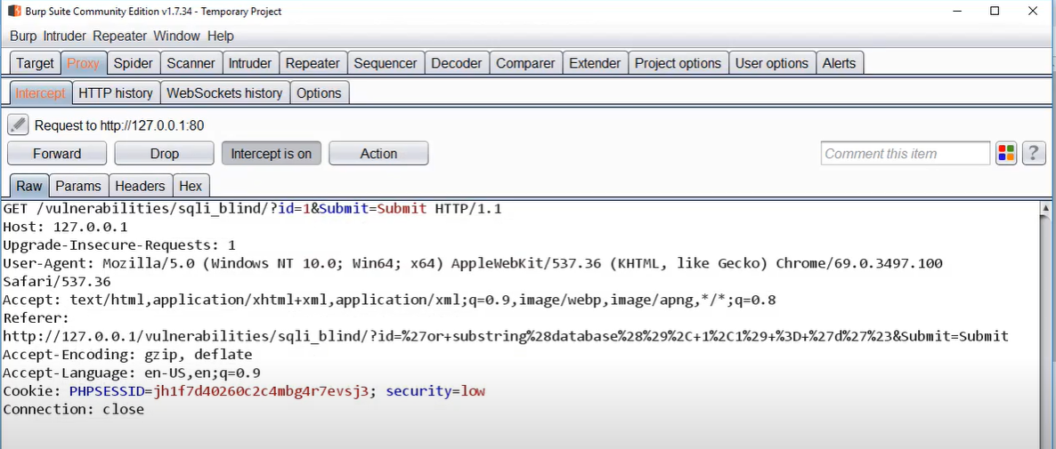

*Sending a GET request to capture relevant information*

*Targeted client’s web application*  *user ID*

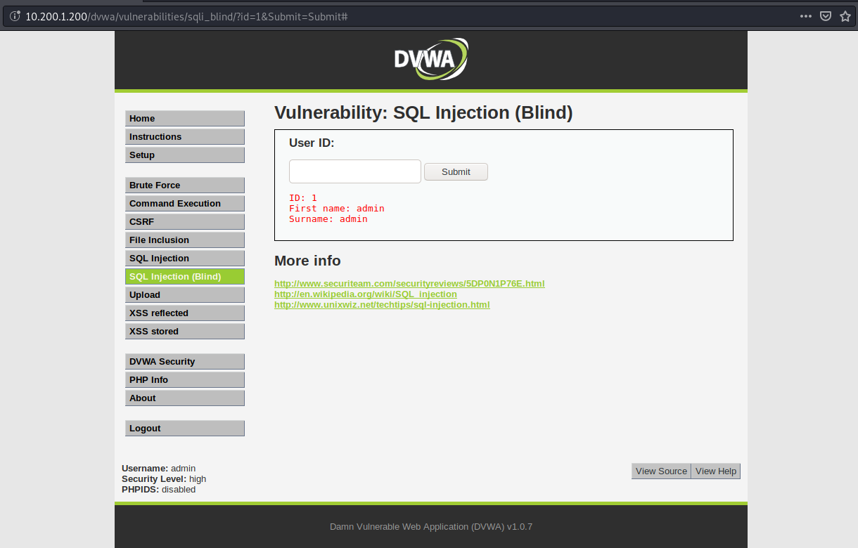

Evaluating the use of cookies

Website uses cookies to store confidential data such as login credentials, bank details and personal information like shipping address and contact details.

Cookies travel across the internet. They are used by ad services and analytics services. So these cookies bounce around from server to server all across the globe. If the connection is not secure, a hacker can easily intercept and steal these cookies.

## 

## 

## 

## There are few methods of stealing cookies, for example; packet sniffing and exploiting a vulnerability called cross-site scripting.

Cross site scripting

A hacker can enter their own malicious codes which will be sent to the database. Once inside, the code will get executed. There are numerous codes hackers can insert into the website to run all sorts of malicious activities like creating a new website admin or stealing cookies.

Once the code is executed, the hackers are able to retrieve your session cookie and session ID. **They will be able to recreate your session and pose as you on that website.**

2)Progressing to the main part of the simulation, the team will be using an important application which is known as the SQLmap, it is a powerful open source penetration testing tool that automates the process of detecting and exploiting SQL injection flaws and taking over database servers.

*(For reference: SQLmap)*

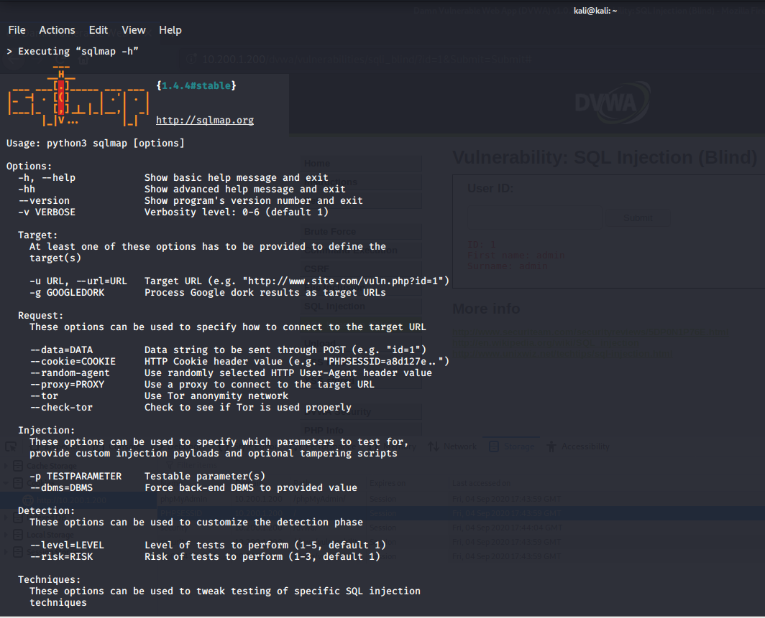

The saved cookies sessionid and its targeted URL are intended to use on SQLmap to find the first query of the name of the database

Here are the steps:

*1) Command: sqlmap -u 'http://10.200.1.200/dvwa/vulnerabilities/sqli_blind/?id=1&Submit=Submit#' --cookie="security=low; PHPSESSID=5bfb5e62bcc19eceadc8f0eb94bf031d" --dbs*

**[Finding the names of the database that is being used by the web application]**



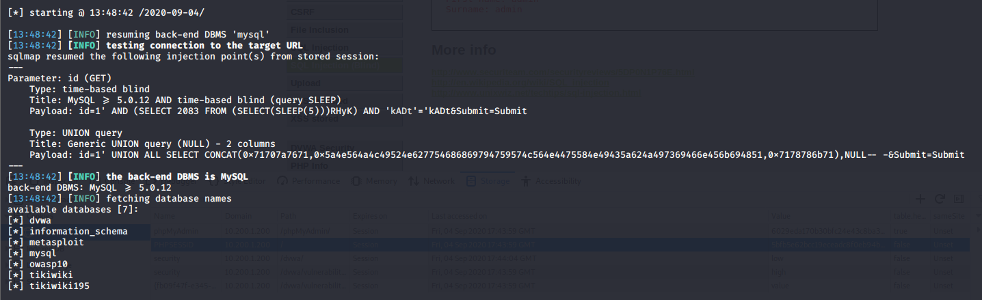

*2) Command: sqlmap -u 'http://10.200.1.200/dvwa/vulnerabilities/sqli_blind/?id=1&Submit=Submit#' --cookie="security=low; PHPSESSID=5bfb5e62bcc19eceadc8f0eb94bf031d" -D dvwa --tables*

**[Now we have enumerated the names of the database, we can now plug it into our next command and list all of its tables. Here we can see, they have guestbook and users.]**



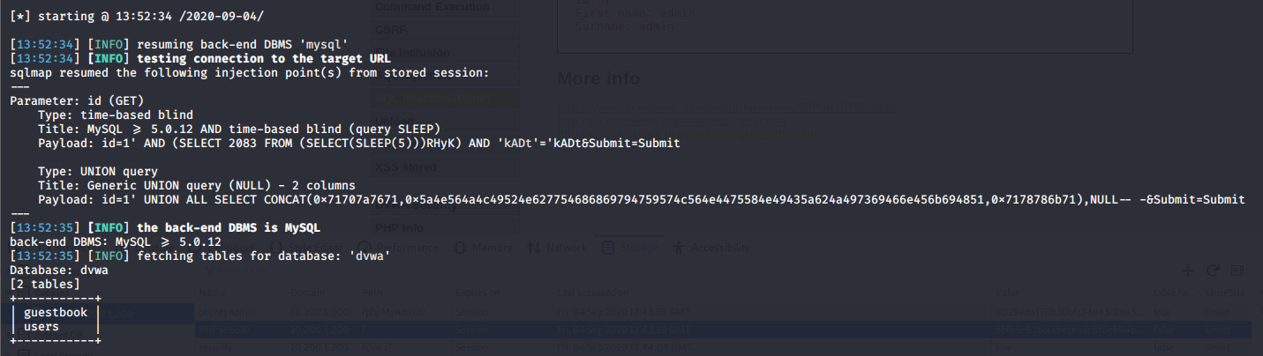

*3) Command: sqlmap -u 'http://10.200.1.200/dvwa/vulnerabilities/sqli_blind/?id=1&Submit=Submit#' --cookie="security=low; PHPSESSID=5bfb5e62bcc19eceadc8f0eb94bf031d" -D dvwa -T users --columns*

**[Now, the columns in the users’ tables]**



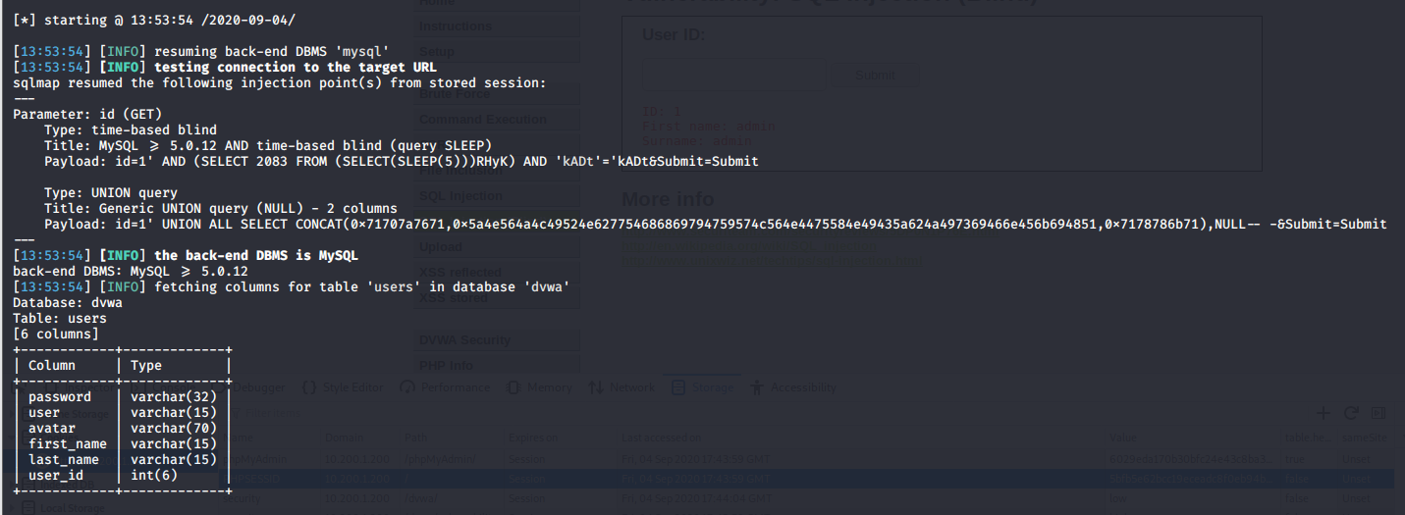

*4) Command: sqlmap -u 'http://10.200.1.200/dvwa/vulnerabilities/sqli_blind/?id=1&Submit=Submit#' --cookie="security=low; PHPSESSID=5bfb5e62bcc19eceadc8f0eb94bf031d" -D dvwa -T users -C user,password,first_name,last_name --dump*

**[Last query, dumping the users’ tables]**



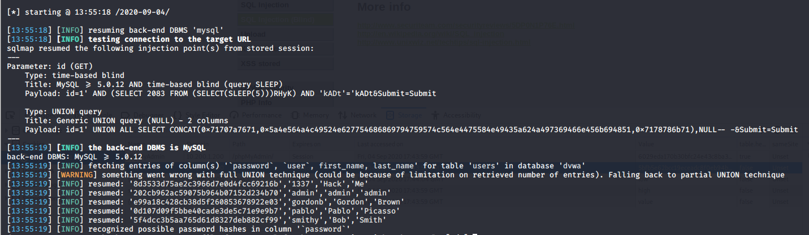

**4) Over here, if SQLmap finds any sort of password hashes, they are capable of cracking the password for us.**

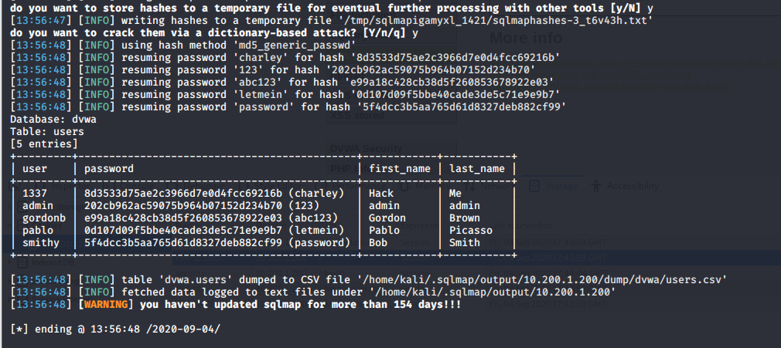

**Conclusively, we’ve successfully exploited the vulnerabilities and managed to mapped out the database and steal the user credentials.**

Here are list of the commands used and their use definitions:

|  |  |
| --- | --- |
| -u | URL to scan |
| --dbs | Enumerate database |
| -D | DBMS database to enumerate |
| --tables | Enumerate DBMS database tables |
| -T | DBMS database table(s) to enumerate |
| --columns | Enumerate DBMS database table columns |
| -C | DBMS database table(s) to enumerate |
| --dump | To grab all the data |

Essentially, we were able to produce a user report based on the information that we retrieved.

As a result, we were able to conclude the end of our vulnerability testing assessment.

**User Report**

|  |  |  |  |  |
| --- | --- | --- | --- | --- |
| user_id | user | password | first_name | last_name |
| 3  1  2  4  5 | 1337  admin  gordonb  pablo  smithy | charley  123  abc123  letmein  password | Hack  admin  Gordon  Pablo  Bob | Me  admin  Brown  Picasso  Smith |

**Recommendations**

**Due to the impact to the overall organization as uncovered by this penetration test, appropriate resources should be allocated to ensure that remediation efforts are accomplished in a timely manner. While a comprehensive list of items that should be implemented is beyond the scope of this engagement, some high level items are important to mention.**

*To prevent SQL injection attacks*

Resurgence Security recommends the following:

* **Clear or disable cookies:** Clear cookies regularly to get rid of any sensitive information stored in browser
* **Avoid storing sensitive data:** Storing credit card information on websites and saving passwords on web browsers could put you at a risk getting them stolen.
* **Update and patch:** Vulnerabilities in applications and databases that hackers can exploit using SQL injection are regularly discovered, so it's important to apply patches and updates to your Window OS as soon as practical.
* **Firewall:** Consider a web application firewall (WAF) – either software or appliance based – to help filter out malicious data. Good ones will have a comprehensive set of default rules, and make it easy to add new ones whenever necessary. A WAF can be particularly useful to provide some security protection against a particular new vulnerability before a patch is available.
* **Habits of changing password:** change the passwords of application accounts into the database regularly.
* **Don’t use dynamic SQL when it can be avoided**: used prepared statements, parameterized queries or stored procedures instead whenever possible.

**Conclusion**

To summarize, Resurgence security had detected 12 security vulnerabilities in LionHealth’s web application.

We strongly recommend that LionHealth should not overlook the findings encountered in this report. If these vulnerabilities/recommendations are dealt with and fixed, the organisation will find that the defence-in-depth posture of the system will improve significantly.

We also recommend that in line with good security practice, LionHealth should conduct inspection and testing occasionally to ensure that neither intentional nor inadvertent changes have compromised their systems, and that new vulnerabilities have not become a threat to them.